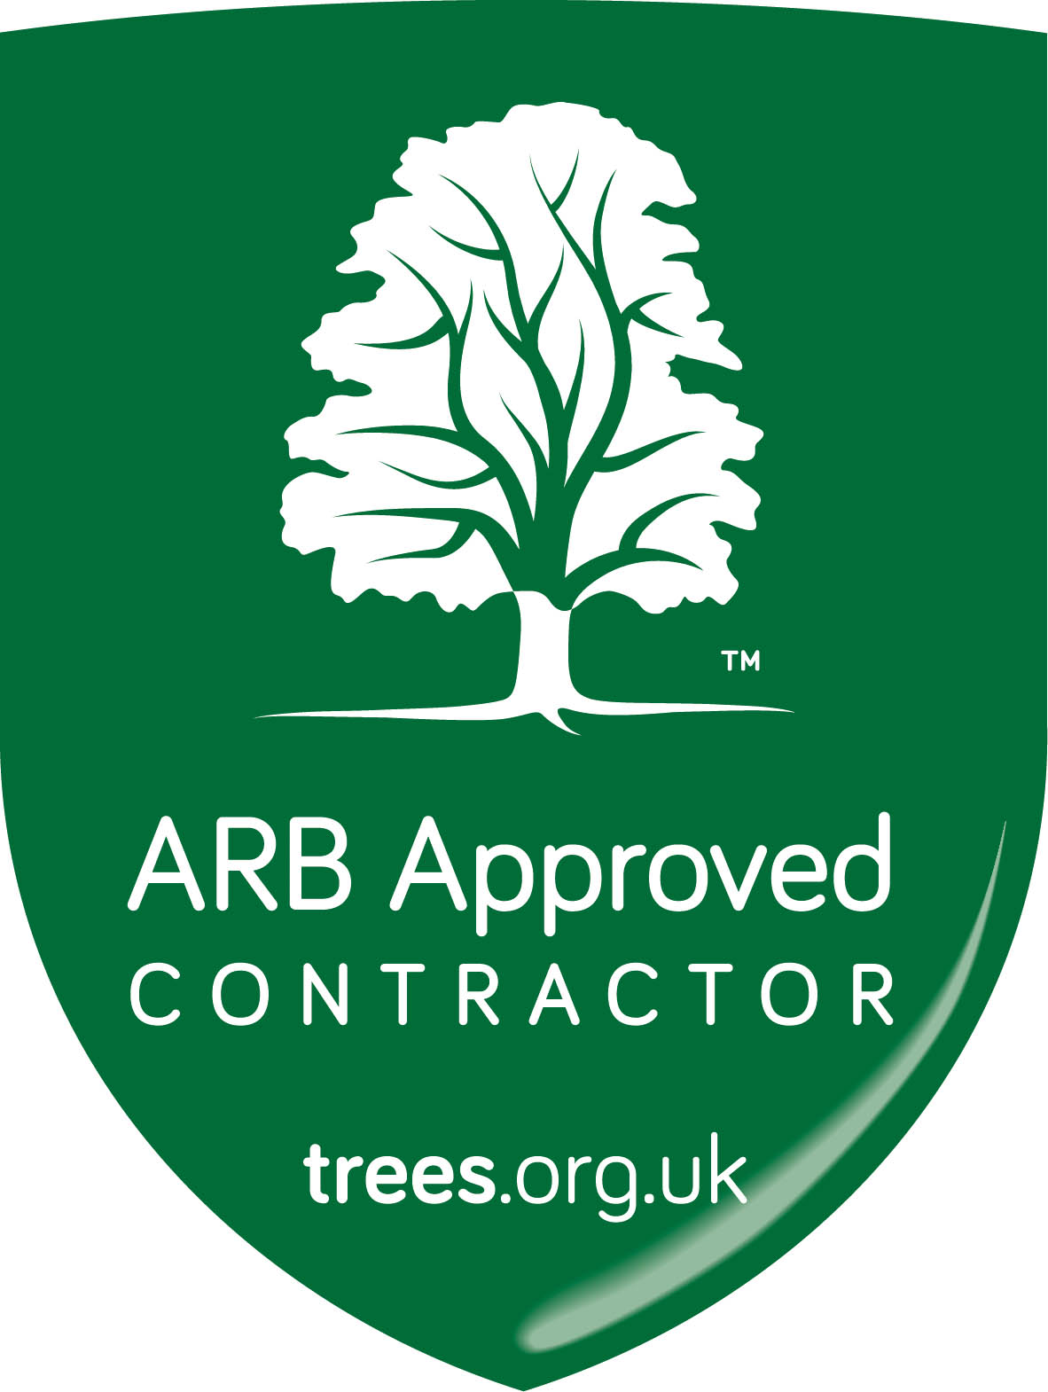
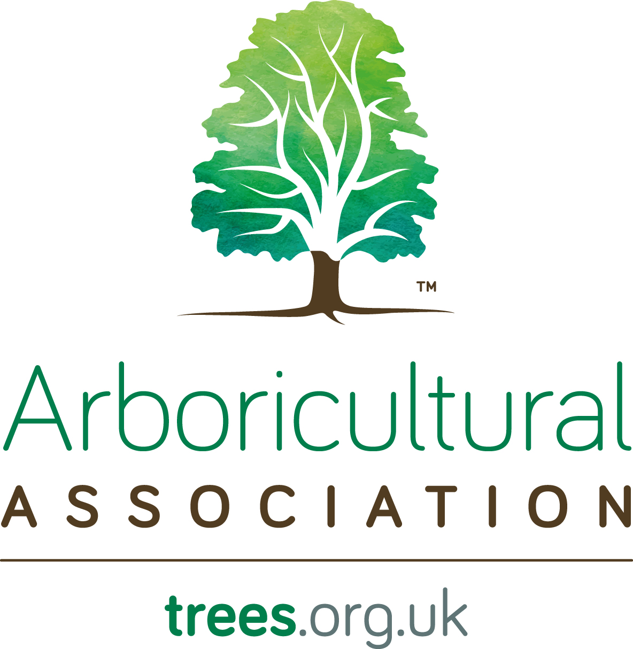
ARB Approved Contractor Application Form
To be completed by the person(s) who will be the ArbAC Manager(s):

Business Details:
Business Name:
Managers Name: |  |  |  | Qualifications:  (see Manager(s) Criteria pg 7)
Managers Name (2):  (if applicable) |  |  |  | Qualifications:  (see Manager(s) Criteria pg 7)
Health and Safety responsible person
(if different from above)
and qualifications:
Business Address:
Line 1: |  |  |  | Company Tel:
Line 2: |  |  |  | Mobile:
Line 3: |  |  |  | Company Fax:
Town: |  |  |  | Website:
County: |  |  |  | Email:
Postcode:
Country
Type of company (please select one):
Sole Trader |  |  | Partnership |  |  |  | Limited Company
Education |  |  | Utility |  |  |  | Retired
If ‘Other’ (e.g. local authority), please specify:
Date of formation of business or registration of company:
Company registration number (if applicable):
If member of a group of companies, name of parent company:
If member of any other SSiP Schemes, please list them here e.g. CHAS / SafeContractor / SMAS:

Size of business (see definition pg 6) | Tick one |  | No. employed staff | No. self-employed staff
Up to 5 people
6 - 9 people
+ > > >
10 - 19 people
+ > > >
20 - 49 people
50+ people
Multi-site
+ +

Names of proprietor, partners, directors or managers of company | Position in company and date of commencement | Professional qualifications | Years in industry | Membership of other professional bodies
ARB Approved Contractor Background Manager Information
Please give details of all skills updates, workshops, training courses, seminars, conferences attended within the last
12 months as part of your Continuing Professional Development (CPD).
Manager 1

Manager 2 (if applicable)

Referees
Detail of three clients for whom the company has carried out arboricultural contracts within the last 12 months, one of which should ideally be a local authority.
Name | Organisation | Address | Email Address

Enforcement action
You must provide details of any enforcement notices or prosecutions served on your business in the last 3 years
by the Health & Safety Executive (HSE) or local authority (LA) in respect of breaches of H&S legislation, and
local planning authority (LPA) or Forestry Commission (FC) in respect of breaches of tree protection legislation.
A notice or prosecution will not debar your business from CHAS registration by the AA, nor approval as an ArbAC,
but failure to declare one will.
APPLICABLE? NO YES (if YES please provide details and evidence of corrective actions)

Declaration
I apply for an assessment to become an ARB Approved Contractor and I have:
read and understood and agree to meet the Standard of the Scheme
understood the consequences of not maintaining the Standard of the Scheme
read and understood and agree abide by the Association’s Code of Ethics and Code of Professional Conduct.
I enclose with this application
the insurance questionnaire and a copy of my insurance policy documentation
a copy of the business’s health and safety policy including a signed and dated policy statement
the appropriate assessment fee (see Table 5 page 18) including VAT.
To the best of my knowledge the information on this application form is true and correct.
Manager 1
Signed: |  | Date:
Manager 2 (if applicable)
Signed: |  | Date:

Please send your completed application form and ALL associated documentation by email to arbac@trees.org.uk or by post to the
Arboricultural Association, The Malthouse, Stroud Green, Standish, Stonehouse, Gloucestershire GL10 3DL.
Please make cheques payable to Arboricultural Association Trading Ltd or payment by BACS, Account No.: 2101 9533, Sort Code: 60-18-46.

ARB Approved Contractor Insurance
Questionnaire

You may need to refer to your insurance provider for assistance here.
Insured:
Trading as:
Address:
Telephone:
Business description:

1. Employers’ Liability

Name of insurer:
Address of insurer:
Policy number:
Expiry date:
Limit of indemnity:
Does the policy cover:
(a) | Indemnity to Principal |  | Yes / No
(b) | Contractual liability |  | Yes / No
(c) | Use of chainsaws and power driven machinery |  | Yes / No
Detail exclusions:

2. Public Liability

Name of insurer:
Address of insurer:
Policy number:
Expiry date:
Limit of indemnity of any one accident:
Is this limit reduced for any specific risks? |  | Yes / No
If so, give details:
Policy excess:
Detail exclusions that would apply to any work being performed in the insured’s capacity as contractor or subcontractor

Does the policy cover:
(a) | Indemnity to Principal | Yes / No
(b) | Contractual liability | Yes / No
(c) | Fire and explosion | Yes / No
(d) | Tree felling without restriction on height or distance from property | Yes / No
(e) | Damage to underground services | Yes / No
(f) | Burning of debris | Yes / No
Is Products Liability included? |  | Yes / No
If so, please confirm indemnity limit applying:

3. Declaration
We undertake to maintain appropriate insurance cover at all times and advise the Arboricultural Association immediately in writing in the event that any of the above policies are:
(a) | Cancelled
(b) | Not renewed, or
(c) | Altered such that the extent of policy protection afforded is reduced or amended in any way from that originally advised.

Signed: |  | Name:
Date:

For and on behalf of the ArbAC.

