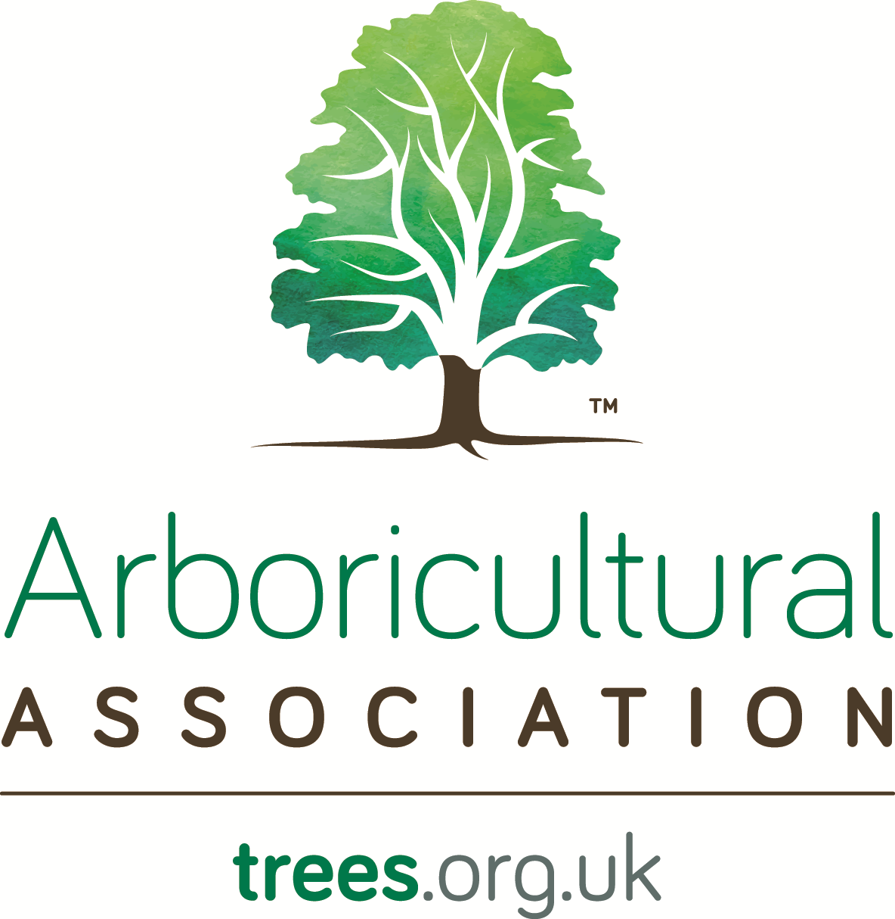
Becoming a Fellow
Information and Application Pack

Introduction
Fellowship of the Arboricultural Association (AA) is the highest grade of AA membership and is widely respected both within and outside the industry. Fellowship is awarded to Professional Members of the AA, recognising an individual’s experience, contribution and achievements in the industry.
The AA is keen to see its members progress to Fellowship and welcomes applications from all branches of the industry. Applications for Fellowship are considered by the AA Professional Committee.

Guidance
This information and application pack sets out the criteria for Fellowship and how to prepare and submit your application. If you have any queries please discuss them with the Membership Officer at the AA Head Quarters (AA HQ) by calling 01242 522152 or emailing membership@trees.org.uk. Your application will be checked by staff at AA HQ for completeness, and validated, before being passed to a panel of members of the AA Professional Committee who will assess and determine the anonymized application.

The assessors will make their decision based solely on the information contained within your application. For this reason it is vital that you carefully consider this guidance and provide a comprehensive submission. If it is incomplete or deficient at the validation stage it will be returned with feedback.

A successful application for Fellowship will demonstrate:

- A minimum of five consecutive years AA membership at Professional grade immediately prior to applying to become a Fellow

- Extensive professional experience in one or more areas of arboriculture, and theoretical understanding in others;

- Comprehensive understanding of the values and principles of arboriculture, and how these shape advice and outcomes in your arboricultural practice;

- A suitable record of contribution to the profession.

The process focuses on your dedication, experience and achievements since becoming a Professional Member of the AA; as well as your contribution to the Association.

Criteria - In applying for Fellowship applicants are expected to show the highest level of accomplishment during their career. The criteria on which your application will be assessed include:
- Length of Professional Membership
- Professional experience and expertise
- Personal, professional and management responsibilities
- Continuing Professional Development (CPD)
- Academic study or specialist skills
- Contribution to the Arboricultural Association
- Contribution to the arboricultural profession through the dissemination of skills & knowledge
- Supporting statements from two referees

This form must be used for your application and should be accompanied by a word processed document with illustrations, photographs and other appendices as appropriate, which describe the full extent of your relevant skills, knowledge, experience and understanding of arboriculture. It should refer to relevant examples or cases, and explain how your work has been informed by professional challenges. Formal training, independent learning, and continuing professional development (CPD), should be identified and referenced chronologically.

You may provide evidence such as certificates, diplomas, CPD certificates, and records of your work. Case studies can also be very useful in illustrating your knowledge, and experience. It is suggested that you submit between two and four case studies in support of criterion 2 [see table below], each of which should be no more that 1000 words long, but may be supplemented with drawings and photographs. It is important to remember that your case studies should not just be a description of the situation, but should demonstrate how the application of your professional knowledge and experience led to a positive outcome. For example:

- A complex practical operation where your skills, experience and knowledge were key to its successful and proficient execution. This will include production of a detailed method statement, risk assessment and plan of work`
- A difficult planning application where your advice was key to your client/the applicant getting planning consent or discharging planning conditions
- Identifying the cause(s) of a valued tree going into decline and recommending remedial measures, which resulted in the tree's improved health/vitality
- Managing the expectations of a tree owner who is intent on having their trees removed for fear of structural damage
- Development, and subsequent delivery, of a 'customer specific' skills training course requiring adaption and application of existing knowledge to achieve an effective outcome. This will include production of a lesson/training plan and course content etc
- Representing your client or employer in a TPO or planning appeal via a public enquiry

Usually, an applicant will have core experience or training in one or more disciplines relevant to arboriculture, and supplement this with a broad understanding of related arboricultural practices. You are not expected to have in-depth professional experience in all aspects of arboriculture, however it is essential to describe your widest relevant experience.

If you have had an appeal upheld against you through the AA appeal process in relation to your work in the last two years, the AA reserves the right to not consider your application. If this is relevant to you, in the first instance please discuss your wish to apply for Fellowship with the Membership Officer at the AA HQ who will refer the matter to the chair of the Professional Committee.

If you have had any Crown, County or Civil Court judgements against you in relation to your work in the field of arboriculture, the AA reserves the right to not consider your application. If this is relevant to you, in the first instance please discuss your wish to apply for Fellowship with the Membership Officer at the AA HQ who will refer the matter to the chair of the Professional Committee.

Referees
Your application must be supported by two of your peers (Referees) who, unless otherwise agreed, are existing Fellows of the AA, or Fellows of the Institute of Chartered Foresters (ICF).

Referees will have known you for at least two years and have a considerable insight into your knowledge and career to date. Only one of your referees can be from your current employer, in your immediate work group or have a commercial link with you. Your relationship to both your referees should be declared.

Each referee should provide you with a concise letter of support (no more than 500 words) that strictly focuses on validating some or all of the criteria information you have provided with your application.

Referees should not mention the applicant by name other than in the title in order to maintain their anonymity. Your referees may be contacted by the AA if further details supporting your application are required so please ensure they are aware of this and provide contact details, including an email address if they have one and day-time telephone number, as well as their name and membership number of the AA or ICF.

Use of Post Nominals
Details relating to the use of post nominals can be found on the AA Website
Data Protection and Privacy Policy
Details relating to the data protection and privacy policy can be found on the AA Website

Continued Professional Development
Fellows should note that CPD is an essential requirement for on-going Fellow membership; the current requirement is 72 hours over a three year period. A form for recording CPD is available from the AA Website if required.

Right of Appeal
If you are unsuccessful in your application for Fellowship there is a right of appeal. Our Appeals Procedure is available to view on our website.
Your Application

I am seeking to upgrade my membership to Fellow status.
Surname: Forename(s):
Address:
Postcode:
Telephone Number:
Mobile Number:
Email Address:
Date of Birth:

Membership number:

Declaration

I wish to apply for membership of the Arboricultural Association.
- If accepted I will observe the Rules of the Association as set out in the Memorandum and Articles of Association, it's Code of Ethics and Code of Professional Conduct, and
- I will endeavour to further the objectives of the Association, and
- I have read the Notes on Promotion and Use of the AA Logo. I will not use the Association’s logo in my advertising or on my stationery unless authorised to do so in writing by the Arboricultural Association, and
- I have read the Notes on Data Protection and Privacy Policy
- I will cooperate with the Association should it choose to undertake an investigation into any complaint made against me
- I understand that if accepted as a Fellow Member of the Arboricultural Association I will become entitled to use the initials “FArborA” only after written confirmation from the Association
- I understand that if my subscription to the Arboricultural Association lapses at any time I will cease to be entitled to use the initials “FArborA” after my name
- I understand that if subsequent to a membership lapse I rejoin the Association, Fellow Membership can only be regained by fulfilling the Fellow Membership requirements applicable at the time of membership renewal
- I understand that Continuing Professional Development is an essential requirement for on-going Fellow Membership and that failure to engage in CPD and to provide evidence when requested may jeopardise my future entitlement to the grade of Fellow Member of the Arboricultural Association
- I confirm that the enclosed documentation is correct to the best of my knowledge.

Name:

Signature:
If completing this form electronically you can insert an electronic signature or alternatively we will accept your email submission as a statement of intent in place of a physical signature.

Date:
In all but exceptional circumstances your application should be submitted electronically. It should include a word processed document with illustrations, photographs and other appendices as appropriate. All material should be clearly referenced to each criterion and indexed in the table below.

Your submission will be assessed anonymously so please avoid references to your name or business name in your application submission.

Types of evidence prefixed with an "E" are essential and must be included in the application submission.

Table of Criteria

Criteria | Evidence | Page numbers in submission
1. Length of Professional Membership | - E - Professional Membership of the Arboricultural Association for a minimum of five consecutive years immediately prior to applying to become a Fellow.
2. Professional experience and expertise | - E - Demonstration of a level of experience equating to at least five years of professional activity since becoming a Professional Member (this may take the form of a CV)  - E - Between two and four case studies of work which demonstrate the quality and range of professional output that you feel supports your application.
3. Personal, professional and management responsibilities | - Evidence of managing people, finance, information or projects, or a combination of these.
4. Continuing Professional Development (CPD) | - E - A record of at least three years CPD showing a consistent, ongoing and structured approach to learning and development. A minimum of 24 hrs CPD per year is suggested.
5. Academic study or specialist skills | - Details of relevant academic qualifications (for information only and not a criterion of Fellowship).  - Published research or papers in a recognised industry journal.  - Evidence of self-study in a particular field, without being attached to an academic or research post, with clear outputs.
6. Contribution to the arboricultural profession in shaping policy and practice | - E - Working with organisations such as British Standards Institute, National Tree Safety Group, HSE, ICF, London Tree Officers Association or regional tree officer group either through work, or as a volunteer with the AA  and/or  - E - Input to particular projects supporting arboriculture through the AA.
7. Contributing to the arboricultural profession through the dissemination of skills & knowledge | - E - Demonstration of how you have advanced the understanding of arboriculture amongst work colleagues, related professions, the general public, clients or customers.  and/or  - E - Author or editor of published work – For example articles in journals, magazines or information on the web.  and/or  - E - Holding a teaching role in arboriculture or other involvement in education or examining lead bodies.
8. Other | - Any other relevant experience, activity, voluntary work or interests you think demonstrate your commitment to arboriculture.
9. Supporting statements from two referees | - E - Application must be supported by two of your peers (Referees) who, unless otherwise agreed, are existing Fellows of the AA, or Fellows of the Institute of Chartered Foresters (ICF). Each referee should provide you with a concise letter of support (no more than 500 words) that strictly focuses on validating some or all of the criteria information you have provided with your application.

